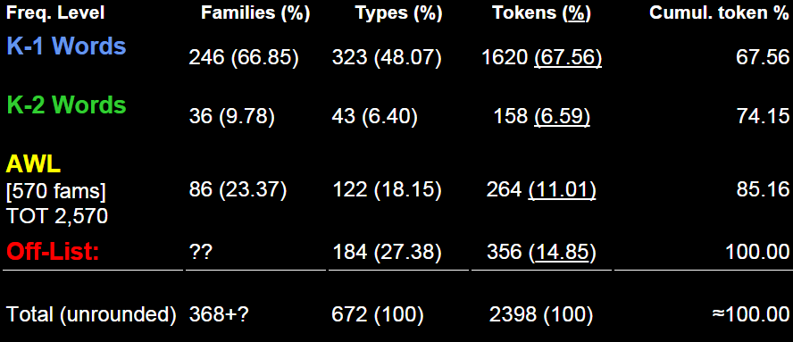

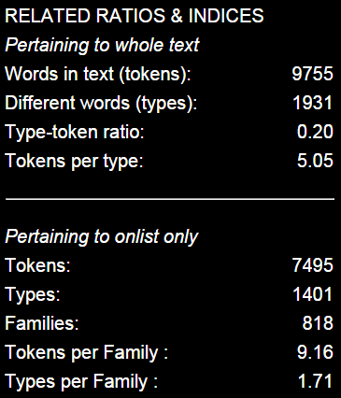

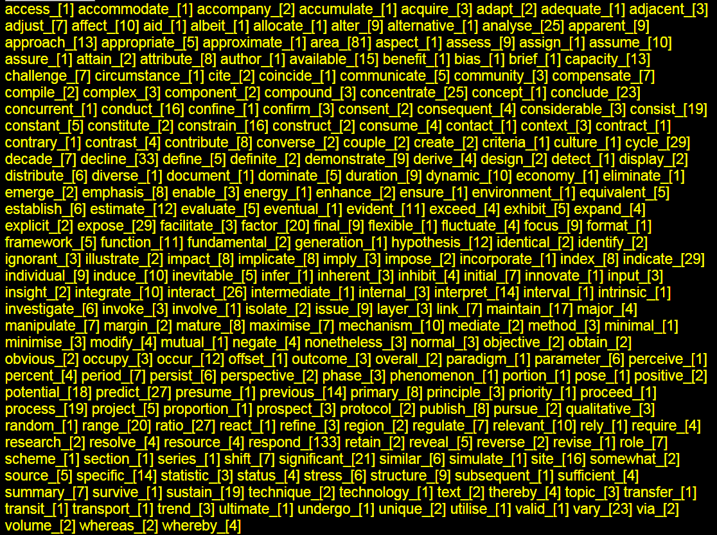
access_[1] accommodate_[1] accompany_[2]
accumulate_[1] acquire_[3] adapt_[2]
adequate_[1] adjacent_[3] adjust_[7]
affect_[10] aid_[1] albeit_[1] allocate_[1]
alter_[9] alternative_[1] analyse_[25]
apparent_[9] approach_[13]
appropriate_[5]
approximate_[1] area_[81]
aspect_[1] assess_[9] assign_[1]
assume_[10] assure_[1] attain_[2]
attribute_[8] author_[1] available_[15]
benefit_[1] bias_[1] brief_[1] capacity_[13]
challenge_[7] circumstance_[1]
cite_[2] coincide_[1]
communicate_[5] community_[3]
compensate_[7] compile_[2] complex_[3]
component_[2] compound_[3]
concentrate_[25] concept_[1]
conclude_[23] concurrent_[1] conduct_[16]
confine_[1] confirm_[3] consent_[2]
consequent_[4] considerable_[3] consist_[19]
constant_[5] constitute_[2] constrain_[16]
construct_[2] consume_[4] contact_[1]
context_[3] contract_[1] contrary_[1]
contrast_[4] contribute_[8] converse_[2]
couple_[2] create_[2] criteria_[1] culture_[1]
cycle_[29] decade_[7] decline_[33] define_[5]
definite_[2] demonstrate_[9] derive_[4]
design_[2] detect_[1] display_[2] distribute_[6]
diverse_[1] document_[1]
dominate_[5] duration_[9]
dynamic_[10] economy_[1] eliminate_[1]
emerge_[2] emphasis_[8] enable_[3]
energy_[1] enhance_[2] ensure_[1]
environment_[1] equivalent_[5]
establish_[6] estimate_[12] evaluate_[5]
eventual_[1] evident_[11] exceed_[4]
exhibit_[5] expand_[4] explicit_[2]
expose_[29] facilitate_[3]
factor_[20] final_[9] flexible_[1] fluctuate_[4]
focus_[9] format_[1] framework_[5]
function_[11] fundamental_[2]
generation_[1]
hypothesis_[12] identical_[2] identify_[2]
ignorant_[3] illustrate_[2] impact_[8]
implicate_[8] imply_[3] impose_[2] i
ncorporate_[1] index_[8] indicate_[29]
individual_[9] induce_[10] inevitable_[5]
infer_[1] inherent_[3]
inhibit_[4] initial_[7] innovate_[1]
input_[3] insight_[2] integrate_[10]
interact_[26] intermediate_[1]
internal_[3]
interpret_[14]
interval_[1] intrinsic_[1] investigate_[6]
invoke_[3] involve_[1] isolate_[2]
issue_[9] layer_[3] link_[7] maintain_[17]
major_[4] manipulate_[7] margin_[2]
mature_[8] maximise_[7] mechanism_[10]
mediate_[2] method_[3] minimal_[1] minimise_[3]
modify_[4] mutual_[1] negate_[4]
nonetheless_[3] normal_[3] objective_[2]
obtain_[2] obvious_[2] occupy_[3]
occur_[12] offset_[1] outcome_[3]
overall_[2] paradigm_[1] parameter_[6]
perceive_[1] percent_[4] period_[7]
persist_[6] perspective_[2] phase_[3]
phenomenon_[1] portion_[1] pose_[1]
positive_[2] potential_[18]
predict_[27] presume_[1]
previous_[14]
primary_[8] principle_[3] priority_[1]
proceed_[1] process_[19] project_[5]
proportion_[1] prospect_[3]
protocol_[2] publish_[8] pursue_[2]
qualitative_[3] random_[1] range_[20]
ratio_[27] react_[1] refine_[3]
region_[2] regulate_[7]
relevant_[10] rely_[1] require_[4]
research_[2] resolve_[4] resource_[4]
respond_[133] retain_[2] reveal_[5]
reverse_[2] revise_[1]
role_[7] scheme_[1] section_[1]
series_[1] shift_[7] significant_[21]
similar_[6] simulate_[1] site_[16]
somewhat_[2] source_[5] specific_[14]
statistic_[3] status_[4] stress_[6]
structure_[9] subsequent_[1]
sufficient_[4] summary_[7]
survive_[1]
sustain_[19] technique_[2]
technology_[1]
text_[2] thereby_[4] topic_[3]
transfer_[1]
transit_[1] transport_[1]
trend_[3]
ultimate_[1] undergo_[1] unique_[2]
utilise_[1] valid_[1] vary_[23] via_[2]
volume_[2] whereas_[2] whereby_[4]
equate_[1]

