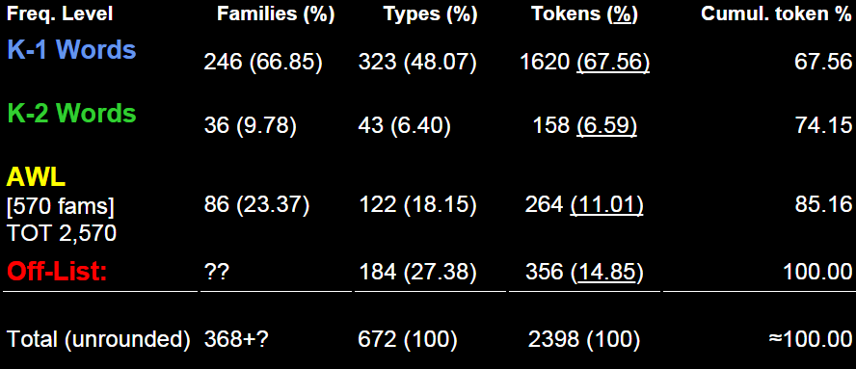

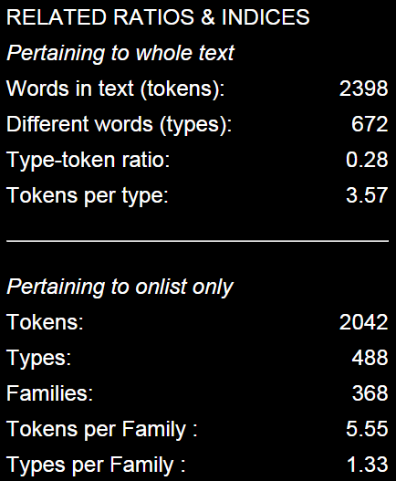

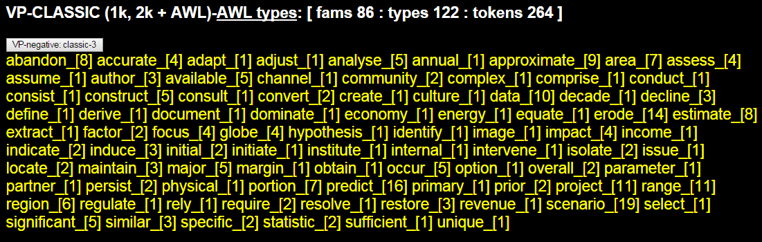

abandon_[8] accurate_[4] adapt_[1]

adjust_[1] analyse_[5] annual_[1]

approximate_[9] area_[7] assess_[4]

assume_[1] author_[3] available_[5]

channel_[1] community_[2] complex_[1]

comprise_[1] conduct_[1] consist_[1]

construct_[5] consult_[1] convert_[2]

create_[1] culture_[1] data_[10]

decade_[1] decline_[3] define_[1]

derive_[1] document_[1] dominate_[1]

economy_[1] energy_[1] equate_[1]

erode_[14] estimate_[8] extract_[1]

factor_[2] focus_[4] globe_[4]

hypothesis_[1] identify_[1] image_[1]

impact_[4] income_[1] indicate_[2]

induce_[3] initial_[2] initiate_[1] institute_[1]

internal_[1] intervene_[1] isolate_[2]

issue_[1] locate_[2] maintain_[3]

major_[5] margin_[1] obtain_[1]

occur_[5] option_[1] overall_[2]

parameter_[1] partner_[1] persist_[2]

physical_[1] portion_[7] predict_[16]

primary_[1] prior_[2] project_[11]

range_[11] region_[6] regulate_[1]

rely_[1] require_[2] resolve_[1]

restore_[3] revenue_[1] scenario_[19]

select_[1] significant_[5] similar_[3]

specific_[2] statistic_[2] sufficient_[1]

unique_[1]area_[5]

