In this handout we will be meeting our friend, Google Drive. This is an easily-used method of storing, sharing, and otherwise utilizing materials, and it is our method for doing so in this class. Thus, welcome to Google Drive.
The first step in this process is for us to invite you to share (“collaborate”) a folder called Academic Vocabulary Development that is on Google Drive. To access this folder you’ll need a Google account, which many of you probably already have.
I will send you an invitation to collaborate on that folder (as shown in the figure below.
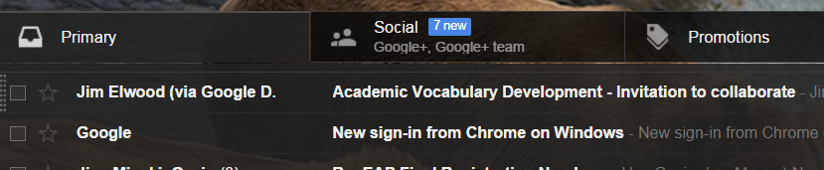
You need to open the email, whereupon you’ll see the following message …
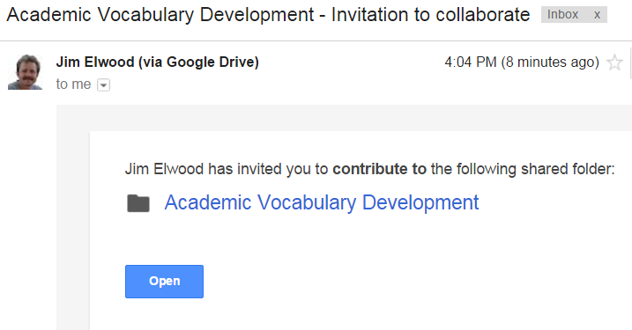
You’ll next simply click “Open.” Clever, huh?

You’ll next see the contents of the folder displayed

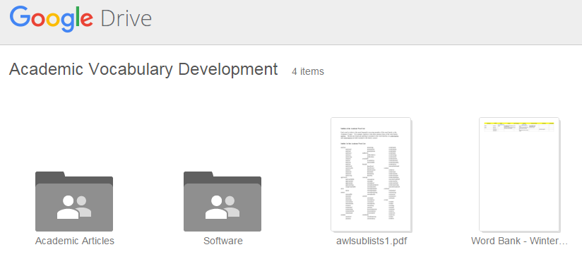

In the upper, righthand corner of this page you’ll see a blue link that will allow you to “Open in Drive”, which will add this folder to your own, personal Google Drive.

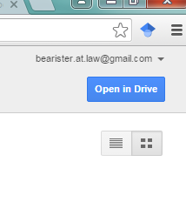

You will then see your own, personal Google Drive displayed as follows:
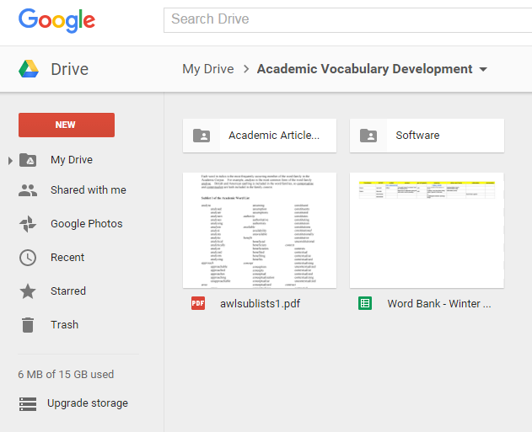
The righthand file is our class Word Bank. You can double-click it to open it, or you can right-click and then open it. You can also download it if you’d like to do so.

Note that you can access Google Drive from your Gmail page. You’ll need to click the dots icon, which will then show the following:

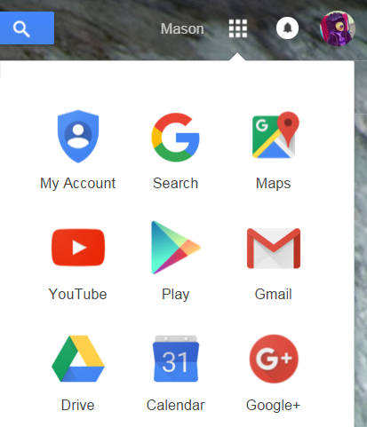

This will send you to the toppage of your Google Drive, which will show all your files and folders. As you can see, Mason has only the Academic Vocabulary Development folder and a file called “How to get started…”

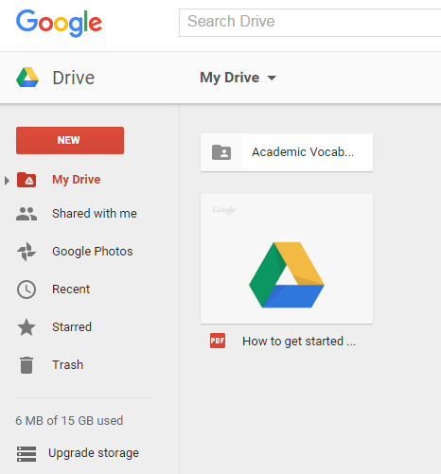

Allow me to finish with two things of note:
1. You can download Google Drive onto your computer, but it is NOT necessary to do so.
2. Do not delete our Word Bank file, please!

