Final “exam” for Professor Elwood’s Tables & Figures class
To be handed in by April 2, 2016 (Saturday)
Your exam includes three parts.

Part 1: Bearing in mind the various facets of tables that we discussed in class, revise Table 4 into an APA-compliant table. A small hint: are notes necessary in this case?
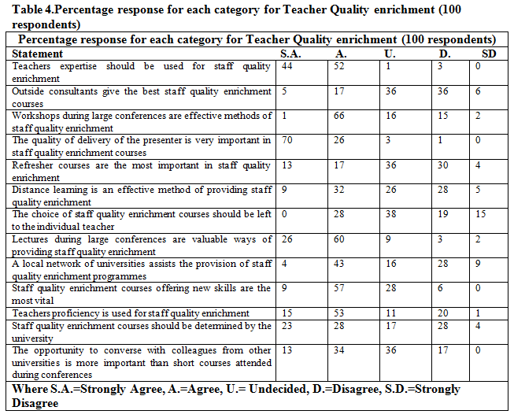

Part 2: In the attached article (Brindley & Scoffield, 1998), you will find several figures. Please critique the figures and the authors’ use thereof (including how the authors talk about the figures in the text). Feel free to suggest how you would change or improve their use of figures.

Part 3: Provide a table or figure of your choosing and critique it (i.e., hand in both the table/figure and your critique of it). The table or figure may be from any article or book, or you may use a table or figure from your own work.

Your exam should be submitted to me via email, and the exam file should be labeled something like student_name_tables_figures_final_exam_2016.04.02

For example,

Elwood_Jim_tables_figures_final_exam_2015.04.04

