Class #1
Class #2
Class #3
Class #4
Class #5
Class #6
Class #7
Class #8

Class #1
February 3, 2015 – Course introduction
Tables & Figures
Dr. James Elwood
elwood.jim@gmail.com OR elwood@grips.ac.jp

Virtual Magnifying Glass

APA = American Psychological Association
(in text)

First, what are these things called tables and figures?

Table: text or numbers
Figure: images, maps, …
Appendix: at the end of the paper … supplementary material

Let’s take a look at some samples, shall we?
table figure examples
diss figures

As you’ll have noticed in the syllabus, I included Occam’s Razor. Why might I have done so?

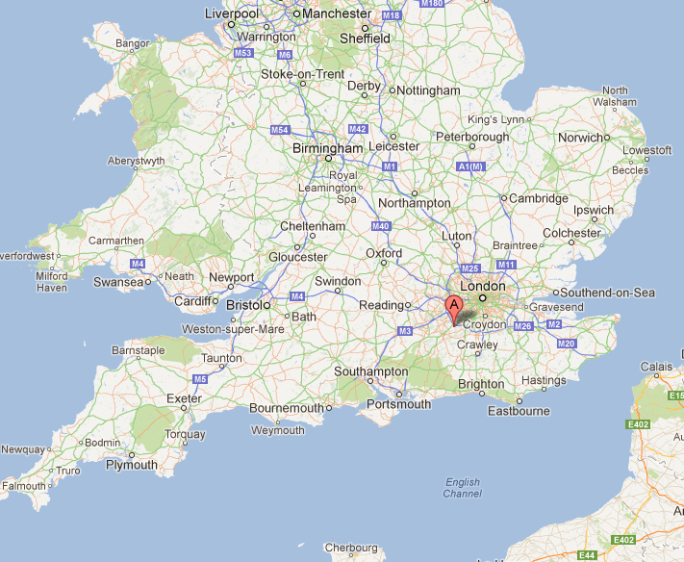
William of Ockham (ca. 1285–1349)
philosopher

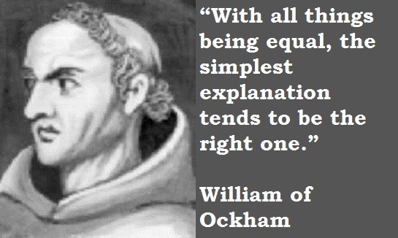

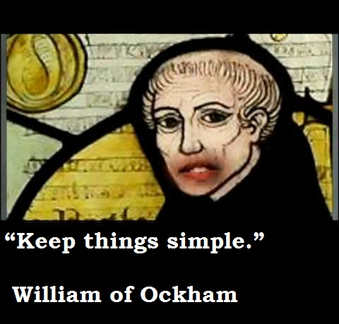

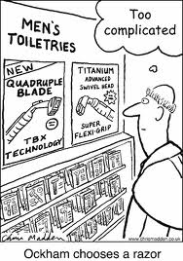

Numquam ponenda est pluralitas sine necessitate [Plurality must never be posited without necessity],

(Often) Simpler is better.
*But not too simple!

Having said that, let’s get better acquainted with building tables in Word, our trusty friend.
- You might be asking this: “In PowerPoint I can make tables, of course – how about using those?”
- You might be asking this: “I can makes all kinds of colorful tables – how about using those?”
- You might be asking this, too: “Why are you so determined to have us use APA style? Aren’t other styles also permissible?”

- Briefly introduce your table / figure.
- Good? Effective?
- How would (could) it be improved?

Your homework this week: find, copy, and bring a table (any table) to class next week. You will be analyzing and explaining it during class.

A hint: As with all things, being parsimonious is a good idea (ask our friend, William). If you have a table from your own research or from some related literature, by all means bring that!

